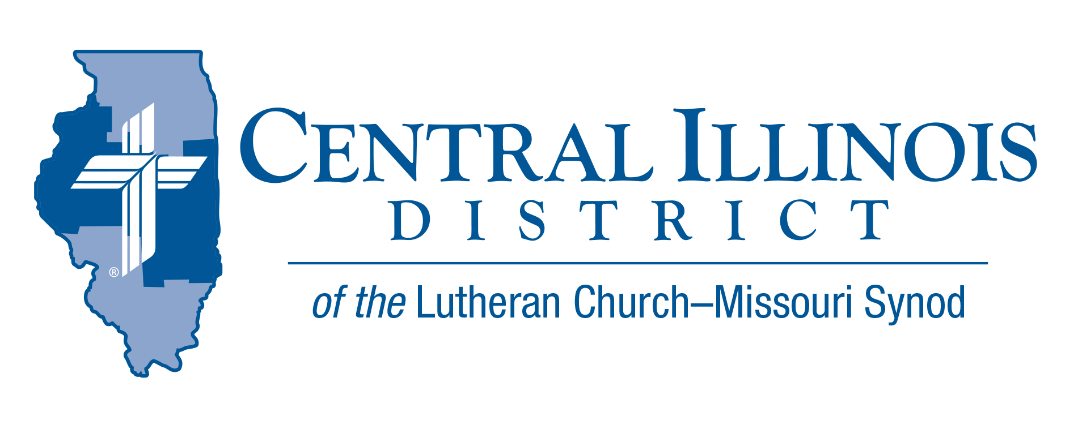
April 2025
News You Can Use
As we celebrate our Lord’s resurrection, let us turn our attention to Mary of Magdala. John records that she was weeping in sadness outside the garden tomb until she heard the voice of Jesus call her by name, talk to her, and send her to share the good news with the others. It is a touching scene and one that captures the Easter joy that overcomes all sadness. The popular hymn, In the Garden, was written to express Mary’s unique experience of literally speaking face-to-face with her risen Savior. It would be wrong to use this hymn out of context to apply it to our perceived spiritual experiences. Rather, our Easter experience takes us to our baptism, where Christ called us by name to belong to Him. That is when we were united with Christ’s resurrection to live new and everlasting lives. In our weekly Divine Service, we continue to experience a mini-Easter as Jesus comes to us, not alone in a garden or on a golf course but gathered together in His house. There, He walks and talks with us through His Word and Sacrament, turning our weeping into a joy that can never be taken away. Then, like Mary, He sends us to share all that He has said and declare to them, “Christ is risen! He is risen, Indeed! Alleluia!”
Rev. Kent Umbarger. St. John’s East Moline

Pray For Our Central Illinois District Missions supported by your church’s Mission Dollars to the District.

Please remember in your prayers Immanuel Lutheran Chapel, a new church started by Immanuel Lutheran Church, Springfield. Pastor Adam Rouse serves both Immanuel Church on Springfield’s northeast side and the chapel on the northwest side at the CID office.

Items of Interest to Share
Mission Education Toolkit part 2
With the District’s next convention on the horizon, July 13-15, an opportunity lies at hand for members of CID congregations to become informed concerning the District’s mission program now and into the future. For your help, “Mission Education Toolkit part 2” is now available on CID website at https://www.cidlcms.org/ministry-stewardship.html Find links there to the entire Mission Commission convention report, plus a couple of documents shared at recent Circuit events about prospects for mission work here in central Illinois.

LWML Save the Date:
LWML CID ladies and pastors will meet in convention under the theme of "Planting Seeds of Faith", based on 1 Corinthians 3:6-7, "I planted, Apollos watered, but God gave the growth. So neither he who plants nor he who waters is anything, but only God who gives the growth." This year they will be celebrating their 80th anniversary!!
The convention will be held Saturday, April 26th, at Zion Lutheran School in Lincoln. Gary Thies of Mission Central in Iowa will be the keynote speaker, and LWML's President, Eden Keefe, will be the national representative attending.
Pre-convention activities will be held Friday afternoon, April 25th, at Zion Lutheran Church in Lincoln. A worship service with communion will also follow a Friday evening dinner. Registration information and other materials have been mailed to the groups,

CID BOARD OF DIRECTORS REVIEW REPORT 03/18/25
Rev. Mark Eddy called the meeting to order. Rev. Mike Burdick gave the opening devotion on Psalm 90, reminding us that the Lord is our dwelling place.
Pastor Adam Rouse led a mission Presentation regarding Immanuel Lutheran Chapel, Springfield. Pastor Rouse gave a history of Immanuel Lutheran Church and Chapel and the current work and teaching on evangelism and outreach studies. Pastor Rouse is hopeful and heartened about where Immanuel Lutheran Chapel is headed.
One-third of CID congregations have registered their delegates to the 2025 District Convention. Please check if your congregation has registered its delegates. Nominations for District President are due by May 18. Thanks to all who have filled out Witness Slips for HB 2827, “The Homeschool Act.” All LCMS Illinois District Presidents signed a letter explaining this bill's adverse effects on our LCMS Schools in Illinois. Because the State legislature has amended the bill, Witness Slips need to be filled out again. The Small Church Summit on June 7th is at Trinity, Taylorville. Every congregation should receive Witnessing Helps posters to aid in teaching Christian witnessing and practicing Christian witnessing.
CID BOD approved funding for CUEnet training for a student interested in future deaf ministry in CID. Trinity, Stewardson’s revised constitution was approved. CID 2026 Compensation Guidelines were approved to include church worker sabbaticals. Sabbaticals are not merely to be “time off,” but rather a period of reflection and renewal to encourage and motivate church workers in their vocation.
The next CID Board of Directors meeting is set for May 20, 2025, at 9:00am.

2025 LCMS YOUTH GATHERING

Registration is now open for our All-Illinois district event! The event will be on Sunday night at the Dome! It will be a meal, entertainment, t-shirt, giveaways, and seating on the floor for the mass event. This event will save you from having to make dinner plans for one night at the Gathering, and you get to go into one of the club areas in the dome! The deadline to register is April 30th! Here is the link: https://www.cidlcms.org/2025nyg.html

