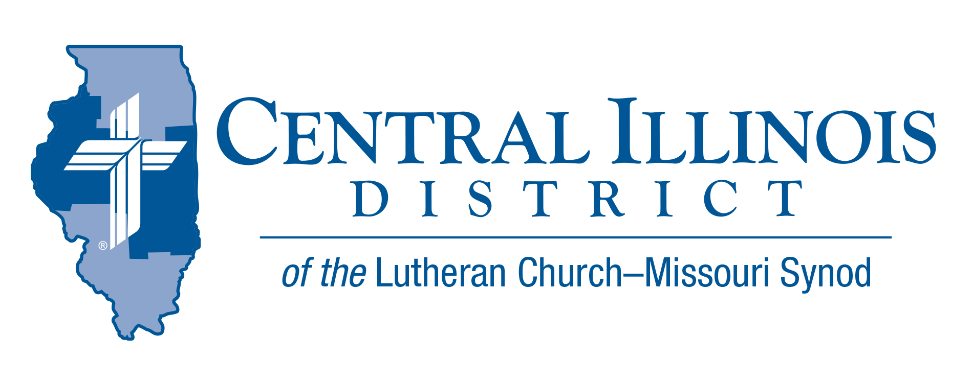
August 2025 midmonth
News You Can Use

St. Bartholomew’s Day is August 24. Bartholomew, who also seems to have gone by “Nathaniel,” is a little-known disciple/apostle.
Almost all we know is that Philip, another early disciple, was found by Jesus, and Philip found Nathaniel (Bartholomew). “We have found the One” about whom the Old Testament testified, Philip said: “Jesus . . . from Nazareth.” When he got the retort, “Can anything good come from Nazareth?”, Philip responded, “Come and see” (John 1:45-46).
Thank God that Nathaniel (Bartholomew) said what he said, and that Philip responded. We echo Philip when we tell the Good News about Jesus today.
Yes, we say, come and see. Specifically, hear the word by which you are born again, which can save you (1 Peter 1:23; James 1:21). Listen. Receive His washing in baptism. Eat His body, drink His blood. “Taste and see that the Lord is good” (Ps. 34:8).

Rev. Ken Schurb- CID

Pray For Our Central Illinois District Missions supported by your church’s Mission Dollars to the District.
Please remember in your prayers all our CID campus ministries, especially Pastor Chris Hull and Immanuel Lutheran Church & Student Center in Macomb, serving students, faculty, and staff at Western Illinois University. And pray for the “Keeping Christ on Campus” campaign, building endowments to help CID support our campus ministries.

Items of Interest to Share

New Dollar for Missions Project:
CID is pleased to announce that sufficient funds have been received for the DFM project to replace insulation in the chancel ceiling at Wittenberg Lutheran Center, Normal. Originally estimated at $10,000, this project will likely be completed at a lesser cost.
The way stands clear for a new project. Immanuel Lutheran Student Center in Macomb was dedicated in 1969, but some of the equipment in the kitchen of the apartment for the live-in student who takes care of the student center (the sexton) has not been replaced since then. The current DFM project is for $11,000 to replace original kitchen equipment in this apartment.

Dollar for Missions Application deadline: The deadline is September 1, 2025, to propose projects to be funded in the following priority order: 1.) new church starts; 2.) mission-focused augmentations to present ministries within CID; 3.) existing CID missions.

Worker Wellness:
In cooperation with Concordia Plans, which is providing a $10,000 grant to CID, the District’s Committee for Human Care and Worker Wellness has developed two goals for 2025-2026:
- To raise gold/platinum status participation in Vitality from 11.5% to 15%
Watch for forthcoming information on a possible District-wide “get you moving” challenge that may accompany this goal.
- To train at least one person for certification as a MHFA (mental health first aid) trainer.
- Are you interested in taking such training?
- Are you simply interested in promoting Church Worker Wellness in general?
- If your answer is “yes” to either of the above, contact Human Care Executive Ken Schurb before the end of August.

OAFC Adult Teams:
Our District, along with two others (South Wisconsin and Southern Illinois) has been awarded a grant by the Bolick Foundation to partner with the Ongoing Ambassadors for Christ organization to develop adult teams of 3 to 5 people per District. These teams would travel to District congregations and offer either 2 and a half day or 5 day events that would provide evangelistic practice by a) canvassing neighborhoods; b) engaging in “dry run” practice of witnessing skills with church members; and c) helping a congregation to begin or to augment its evangelistic efforts in a nearby nursing home.
- Would you be interested in serving on such a team yourself? Do you know someone else who would?
- Might your congregation be interested in hosting such a team to work in your midst?
- If the answer is “yes” to any of these questions, or if you would like more information, please contact Evangelism Executive Ken Schurb.

Stay Connected with your District
Looking for additional information, visit https://linktr.ee/cidlcms or connect with the following items:
- CID’s GatePost (newsletter) Subscribe to the E-GatePost/News You Can Use. Stay connected with us on Facebook and Instagram --Central Illinois District-LCMS

