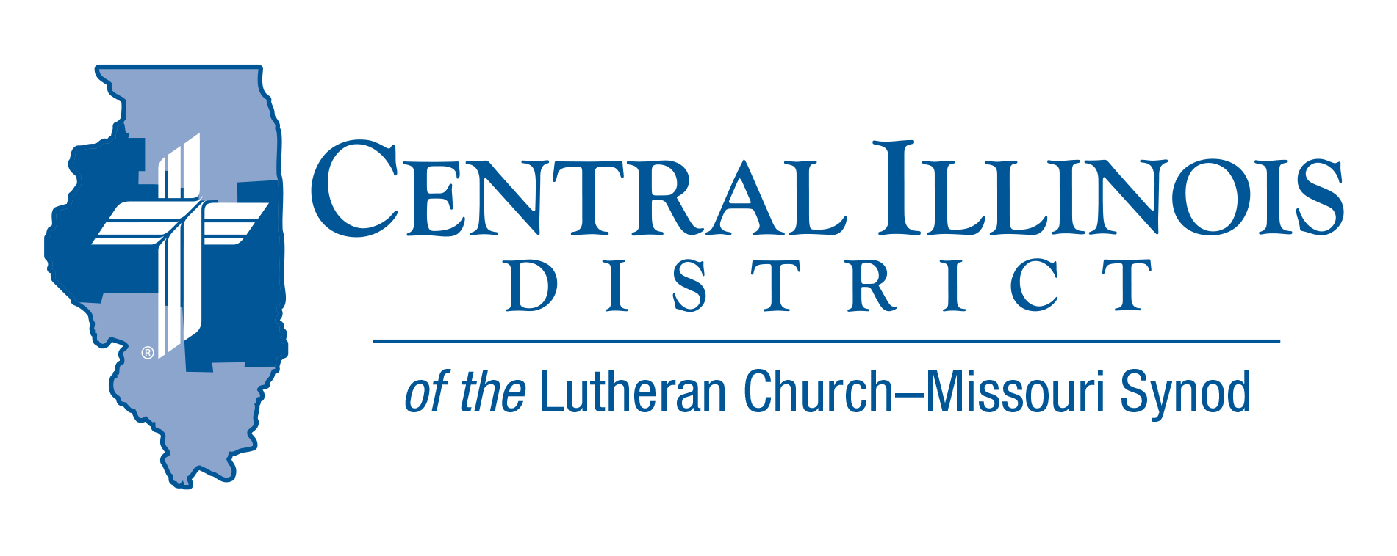
December 2025
News You Can Use

He Has/Is/Will Come

“Amen. Come, Lord Jesus!” – Rev. 22:20b

Advent means “coming.” During this time of the year, the Church prepares for the coming of our Lord. The Advent season begins with our eyes turned to the fact that our Lord will come, returning upon the clouds on the Final Day to usher in the New Creation. With repentance, we mark this season in preparation for that great and final judgement. As the Advent season closes, we transition into the Christmas season, fixing our eyes of faith upon the great good news that our Lord has come – born of flesh and blood, “born of woman, born under the law to redeem those who were under the law, that we might receive adoption as sons.” (Gal. 4:4b-5) In all of this, let us not forget that we are prepared by God for that final day when He will come by His work, from manger to cross to ascension and resurrection, when He had come because He is come to us each and every day in His means of grace. Turn you hearts and minds to His Word. Devote your time and work to receiving His Sacraments. Even as we await His return in glory, He is present with us now by His grace.

Rev. Michael Mohr, CID President

Pray For Our Central Illinois District Missions, supported by your church’s Mission Dollars to the District.
We give thanks for the gift of our Savior’s birth, and we pray for the adherents of various world religions who do not believe that in Jesus Christ the Word became flesh for the salvation of all people. We ask the Lord to shine His saving Gospel light to everyone, and to do so through us. “Thy kingdom come”!

Call the Central Illinois Church Extension Fund
for their latest Investment Rate

Items of Interest to Share

The Small Church Summit for Winter, 2026, will feature a presentation by SID President Heath Curtis titled “The Small Town Lutheran Church.” Sectionals will be on “Shepherding our Strays,” technology in small churches, and safety standards. Saturdays in two locations:
- Hope Lutheran Church, Highland – on Jan. 10 or (if weather is bad then) Jan. 31
- St. Paul Lutheran Church, Lexington – on Feb.21 or (if weather is bad then) Feb. 28
Sign-in will be at 9:30 a.m., opening devotion will commence at 10:00, and closing prayer will be at 2:30 p.m. Register by January 3, 2026 at https://forms.gle/eujwE5hmRC48wF7MA
If you think your church is small, YOU are invited. And everyone is welcome!

CID BOARD OF DIRECTORS REVIEW REPORT 11/25/25
Mr. Scott Breitenfeld (University Lutheran – Champaign) was appointed as lay member to the Board of Directors. Other appointments of lay members were made to fill district commissions. The Evangelism Commission is in need of members for their commission. If interested in serving on the Evangelism Commission, please contact Pastor Ken Schurb. The Formula of Concord study continued on Article I: Original Sin. The 2026 CID Budget was adopted. CID Staff Housing Allowances were approved for 2026.
The 2026 Dollars for Missions projects were approved. They are: Travel expense for Hispanic Ministry at Beardstown and Signage for Wittenberg Campus Ministry in Normal.
Pastor Chuck Olander was thanked for his years of service as Gift Planning Officer for CID.
Current Dollar For Mission Project
Project: Replace original kitchen equipment in the sexton's apartment at Immanuel Lutheran Student Center, Macomb
Immanuel Lutheran Student Center in Macomb was dedicated in 1969, but some kitchen equipment in the apartment for the live-in student who takes care of the student center (the sexton) has not been replaced since then. DFM funds would be used to replace the original kitchen equipment. Amount to be funded: $11,000.00
2026 Youth Bible Bowl
Date: Will be in the spring of 2026. We are still working on the date.
Topic: "The Gospel According to St. Matthew"

The Gospel according to St. Matthew summarizes what we need to know to receive salvation from sin, the devil, and death. St. Matthew's Gospel records the most important teachings of Jesus and the key events in Jesus’ life. Plan to study "the Gospel according to St. Matthew" with youth (junior and senior high [grades 6-12]) as thoroughly as you can, to prepare them to answer questions in your Circuit and at the District Bible Bowl in the spring, and (most importantly) so that by God’s grace and the power of the Holy Spirit they grow in their faith that Jesus truly is the Son of God and our Savior.
Contact Rev Mark Eddy (zionlcms@juno.com) for additional information.

