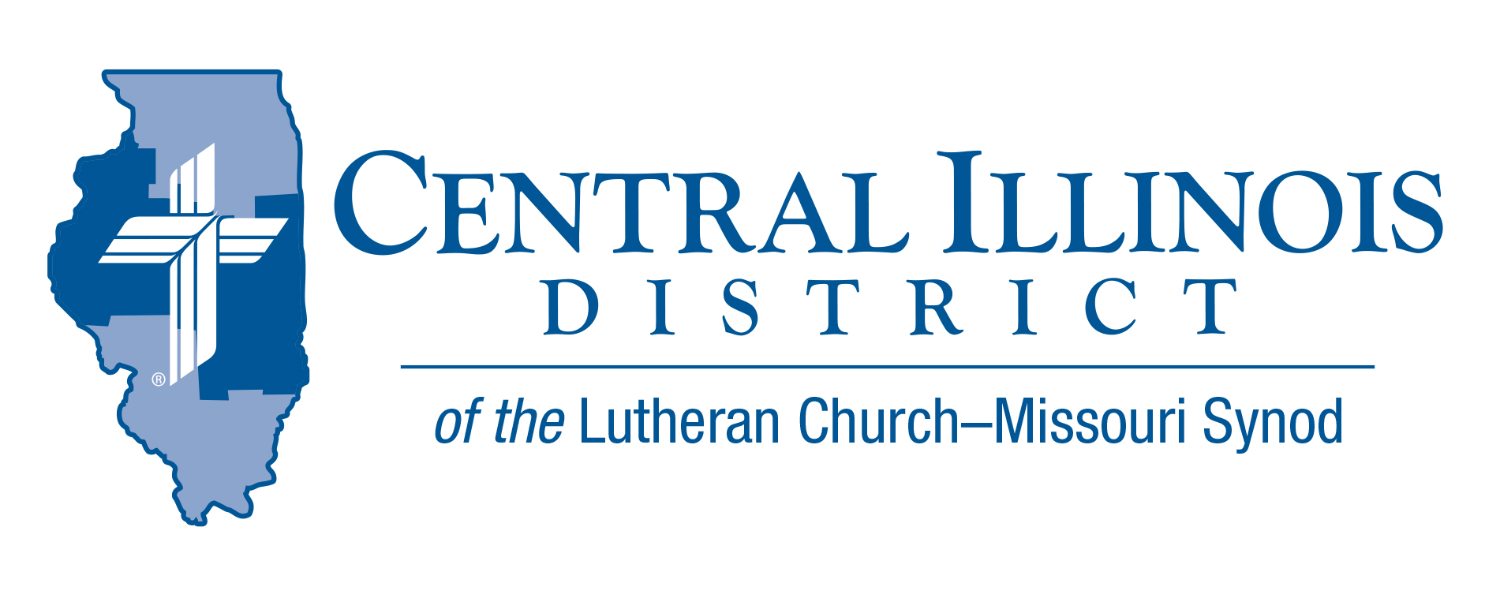
February 2025
News You Can Use
Enough

We learn valuable lessons in life, sometimes in the most unexpected places.
One of the great life lessons I learned was in the Chicago Bus Terminal one Friday night after midnight. While there, I began conversing with an old-order Amish man. He said he was a farmer. I asked how big a farm he farmed and he said it was “big enough.” I asked how much land he farmed. He said “enough”. I asked him how many acres he farmed and he said “enough.” I saw that he was a wise man, content with what he had. For him, it was “enough.”
It became apparent to me that I wasn’t as content as this man but prayed that God would change my heart, so like this gentleman and the apostle Paul, I would be content in any and every situation. Contentment is about faith, knowing that God created and sustains every atom and molecule of this world, believing that He loves us so much that God sent Jesus to suffer and die for our sins, and understanding that He will never leave us or forsake us. Therefore, we can trust that, whether living or dying, He will always give each and every believer “enough.”
Rev. Charles Olander

Pray For Our Central Illinois District Missions supported by your church’s contributions to the District. “Finally, brothers, pray for us, that the Word of the Lord may spread rapidly and be honored.” Please remember in your prayers all our CID campus ministries, especially Immanuel Lutheran Church in Charleston, serving students, faculty, and staff at Eastern Illinois University. And pray for the “Keeping Christ on Campus campaign,” building endowments to help CID support our campus ministries.

Items of Interest to Share
Save the Date – Please plan to attend the Central Illinois District Lutheran Laymen’s District Convention on March 1st, 2025. It will be at Camp CILCA in the new dining hall room. Doors open at 9:00 AM. Lunch will be served. The guest speaker will be past Lutheran Hour Speaker and retired Concordia Seminary President – Dr. Dale Meyer. Registration deadline is Feb 23. Register by emailing Deloris Blessman at delorisblessman@yahoo.com

CID Convention Reminders:
- Convention Date July 13-15, 2025- Springfield, IL
- Overtures and Reports due date: February 26th
- Floor Committee meeting date: March 15th
2025 LCMS YOUTH GATHERING
Looking for information: Ways to Connect:
- CID Lutheran Youth Facebook Group (https://www.facebook.com/groups/249327678480252) – Find the latest district updates and information LCMS Youth Ministry Facebook Group

- End Goals: LCMS Youth Ministry Podcast https://www.kfuo.org/category/lcms-youth-ministry-end-goals/ All things youth ministry and some great episodes on the Gathering! Be sure to check out www.lcmsgathering.com under the Resources tab for tons of information, worksheets, budgeting sheets, etc.
Announcing 2025 Central Illinois District Youth Bible Bowl:

TOPIC: The Life of David (1 Samuel 16 – 1 Kings 2:12) DATE: April 6 (PLACE: a centrally-located venue (usually a church, school, or Camp CILCA, near Springfield) large enough for all the registered teams. AGES: youth involved in their church. If you would like more information, you may contact Pastor Mark Eddy at Zion Lutheran Church, Taylor Ridge, Illinois (zionlcms@juno.com) or 309-795-1063.

Free Ukrainian resources for sharing the Gospel: Great news! The Lutheran Heritage Foundation (a recognized service organization of the LCMS) has just gotten a huge shipment of books carrying two FREE new resources available in Ukrainian, including the classic children's Bible storybook A Child's Garden of Bible Stories and Best of Portals of Prayer. These materials are available to any LCMS church, mission or individual who wants to share the Good News with their Ukrainian-speaking neighbors. To order, send an email to info@LHFmissions.org or call the LHF office at (800)554-0723.

Next Small Church Summit in CID: Feb. 22 in Pekin
Trinity Lutheran Church, Pekin, will host the Small Church Summit (SCS) meeting on February 22. The bad weather date is March 1.
Sign-in starts at 9:30 a.m. Opening devotion will commence at 10:00. Adjournment will be at 2:30 that afternoon.
Before lunch, a presentation on Witnessing Helps (that can be found online at https://www.cidlcms.org/outreach-witness-ministry.html). Copies of the four Witnessing Helps sheets on 1) beginning an evangelistic conversation, 2) listening discerningly to a nonchurched person, 3) making a simple statement of the Gospel, and 4) defending the resurrection will be provided at the SCS.
Lunch will be provided. In the afternoon, interest sessions will include:
SCS is free and available to all congregations of not only CID but also the Southern Illinois District. You need not be from a small church to attend. It works best to bring three or four others from your church. Talk in the car on the way to and from.

Trinity Lutheran Church is at 700 S 4th St., Pekin, IL, 61554-4504. The deadline to register is Tuesday, February 11.
REGISTER NOW for the winter Small Church Summit at https://forms.gle/ iwHhyL2kXhnAAsHV8

