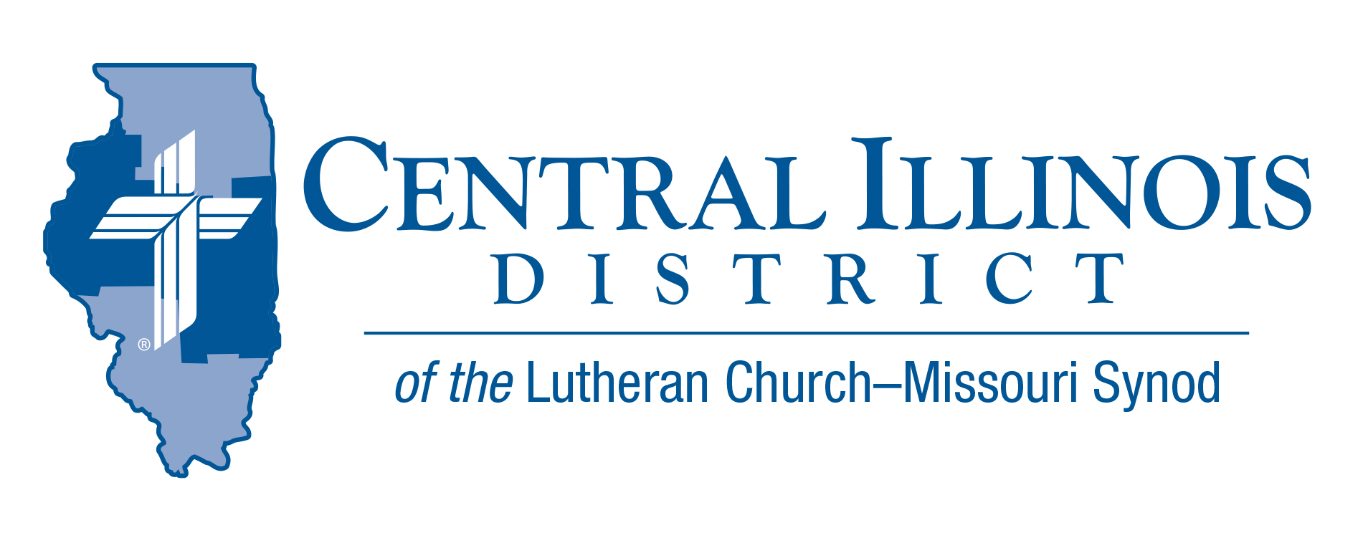
January 2025 mid-month
News You Can Use
There is a story of a glass blower who could make beautiful and intricate vases. One day a man asked him to create a beautiful vase for him. The glass blower agreed. After a few days he showed the completed work of art to the buyer who was delighted with it. He paid the glass blower and started toward home. On the way, he stumbled and dropped the vase. It shattered into hundreds of pieces! The man carefully picked up each piece and brought them to the glass blower. “Can you remake this so that it is exactly like it was before it broke?” he asked. “I’m sorry,” said the glass blower, “that is impossible. I can make you another one.” “No,” responded the man, “I want this same one. It is irreplaceable.” The man walked away heartbroken.
We are God’s treasured creation. We are irreplaceable vessels which hold a greater treasure – the Gospel of Christ. “But we have this treasure in jars of clay to show that this all-surpassing power is from God and not from us.” 2Cor.4:7.
We were broken, shattered, seemingly irreparable. Yet God can do what no person can do. He doesn’t replace us with something or someone else. He re-creates us! In Christ we are made holy, as if we had never been broken. “without stain or wrinkle or any other blemish, but holy and blameless.” Eph.5:27 We cannot clearly see this on our outsides. But God sees it on our insides, in our soul. And when we stand before his glorious throne, we shall be his perfect re-creation on the inside and out. “For the trumpet will sound, and the dead will be raised incorruptible, and we shall be changed.” 1Cor.15:52

Rev. Jeff Harter
Items of Interest to Share

2025 LCMS YOUTH GATHERING
Looking for information: Ways to Connect:
- CID Lutheran Youth Facebook Group (https://www.facebook.com/groups/249327678480252) – Find the latest district updates and information LCMS Youth Ministry Facebook Group

- End Goals: LCMS Youth Ministry Podcast https://www.kfuo.org/category/lcms-youth-ministry-end-goals/ All things youth ministry and some great episodes on the Gathering! Be sure to check out www.lcmsgathering.com under the Resources tab for tons of information, worksheets, budgeting sheets, etc.

Save the Date – Please plan to attend the Central Illinois District Lutheran Laymen’s District Convention on March 1st, 2025. It will be at Camp CILCA in the new dining hall room. Registration begins at 9:00 AM. Lunch will be served. The quest speaker will be past Lutheran Hour Speaker and also retired Concordia Seminary President – Dr. Dale Meyer.

Announcing 2025 Central Illinois District Youth Bible Bowl:

TOPIC: The Life of David (1 Samuel 16 – 1 Kings 2:12) DATE: Saturday or Sunday afternoon, March 29-30 or April 5-6 (to be determined as we try to work around as many young people’ school and sports schedules as possible). PLACE: a centrally-located venue (usually a church, school, or Camp CILCA, near Springfield) large enough for all the registered teams. AGES: youth involved in their church. The CID Youth Bible Bowl is an opportunity for young people in Junior and Senior High School (grades 6-12) to study a portion of God's word each year and meet with other young people of their circuit and the District. If you would like more information, you may contact Pastor Mark Eddy at Zion Lutheran Church, Taylor Ridge, Illinois (zionlcms@juno.com) or 309-795-1063.

Next Small Church Summit in CID: Feb. 22 in Pekin
Trinity Lutheran Church, Pekin, will host the Small Church Summit (SCS) meeting on February 22. The bad weather date is March 1.
Sign-in starts at 9:30 a.m. Opening devotion will commence at 10:00. Adjournment will be at 2:30 that afternoon.
Before lunch, a presentation on Witnessing Helps (that can be found online at https://www.cidlcms.org/outreach-witness-ministry.html). Copies of the four Witnessing Helps sheets on 1) beginning an evangelistic conversation, 2) listening discerningly to a nonchurched person, 3) making a simple statement of the Gospel, and 4) defending the resurrection will be provided at the SCS.
Lunch will be provided. In the afternoon, interest sessions will include:
- Further conversation about the Witnessing Helps
- A session with Mr. Trip Rodgers of CID staff on various available resources
- A session with CID President Michael Mohr on record-keeping in smaller churches, especially during pastoral vacancies
SCS is free and available to all congregations of not only CID but also the Southern Illinois District. You need not be from a small church to attend. It works best if you bring along three or four others from your church. Talk in the car on the way to and from.

Trinity Lutheran Church is at 700 S 4th St., Pekin, IL, 61554-4504. The deadline to register is Tuesday, February 11.
REGISTER NOW for the winter Small Church Summit at https://forms.gle/ iwHhyL2kXhnAAsHV8

CID Convention Reminders:
- Convention Date July 13-15, 2025- Springfield, IL
- Overtures and Reports due date: February 26th
- Floor Committee meeting date: March 25th

