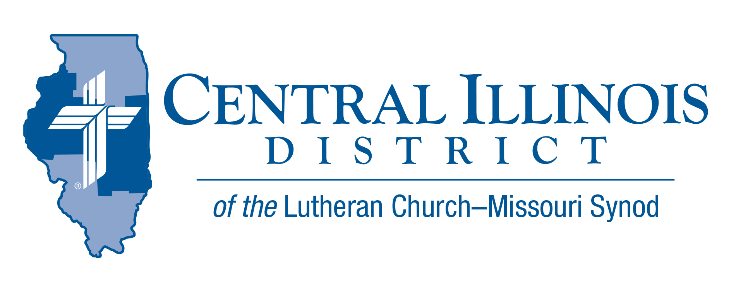
January 2025
News You Can Use
Was it Mrs. Fox, or Mr. Locher? Pastor Watkins, or my friend Dave? Who was it that urged me to give prayer and consideration to serving as a full-time church worker? It was all of them, and many more. And when I was younger, I gave them ample reasons to think I wouldn’t be a pastor. But still, the Lord used many people of the Central Illinois District in the 70s and 80s to nudge and form me into a pastor.
The Lord works through means, and sometimes it’s you He uses. Think about the maturing Christian men and women (they don’t have to be youth) in your congregation whom you could encourage to serve as a Lutheran teacher, musician, or pastor. Pray first, encourage second.
[Jesus said,] “Therefore pray the Lord of the harvest to send out laborers into His harvest.” (Mt 9:38). The fields are His, and the work is His. He will hear and answer your prayers according to His will. You might be encouraging the wrong person, but He’ll work His will. Pray first. Encourage second. That’s a good way to begin the year of our Lord 2025.
- Mike Burdick, St. John’s Effingham
Pray For Our Central Illinois District Missions supported by your church’s Mission Dollars to the District. “Finally, brothers, pray for us, that the Word of the Lord may spread rapidly and be honored.” Dear Father, we pray Thee, give us Thy Word, that the Gospel may be sincerely preached throughout the world and that it may be received by faith and may work and live in us. So we pray that Thy kingdom may prevail among us through the Word and the power of the Holy Spirit, that the devil’s kingdom may be overthrown and he may have no right or power over us, until finally the devil’s kingdom shall be utterly destroyed and sin, death, and hell exterminated, and that we may live forever in perfect righteousness and blessedness (from Luther’s Large Catechism).

Items of Interest to Share

Cellphones, Technology, and Teenagers Presentation
Our Redeemer—Jacksonville ( 405 Massey Ln) will host Pastor Joshua Theilen (Camp CILCA) on Jan. 25th from 6 to 7:30 p.m. There is no cost (freewill offering), but you must reserve a seat by emailing carl.wicklander@gmail.com by Jan. 20. Light refreshments will be served, but no childcare will be provided.

Announcing 2025 Central Illinois District Youth Bible Bowl:

TOPIC: The Life of David (1 Samuel 16 – 1 Kings 2:12) DATE: Saturday or Sunday afternoon, March 29-30 or April 5-6 (to be determined as we try to work around as many young people’ school and sports schedules as possible). PLACE: a centrally-located venue (usually a church, school, or Camp CILCA, near Springfield) large enough for all the registered teams. AGES: youth involved in their church. The CID Youth Bible Bowl is an opportunity for young people in Junior and Senior High School (grades 6-12) to study a portion of God's word each year and meet with other young people of their circuit and the District. If you would like more information, you may contact Pastor Mark Eddy at Zion Lutheran Church, Taylor Ridge, Illinois (zionlcms@juno.com) or 309-795-1063.

Next Small Church Summit in CID: Feb. 22 in Pekin
Trinity Lutheran Church, Pekin, will host the Small Church Summit (SCS) meeting on February 22. The bad weather date is March 1.
Sign-in starts at 9:30 a.m. Opening devotion will commence at 10:00. Adjournment will be at 2:30 that afternoon.
Before lunch, a presentation on Witnessing Helps (that can be found online at https://www.cidlcms.org/outreach-witness-ministry.html). Copies of the four Witnessing Helps sheets on 1) beginning an evangelistic conversation, 2) listening discerningly to a nonchurched person, 3) making a simple statement of the Gospel, and 4) defending the resurrection will be provided at the SCS.
Lunch will be provided. In the afternoon, interest sessions will include:
- Further conversation about the Witnessing Helps
- A session with Mr. Trip Rodgers of CID staff on various available resources
- A session with CID President Michael Mohr on record-keeping in smaller churches, especially during pastoral vacancies
SCS is free and available to all congregations of not only CID but also the Southern Illinois District. You need not be from a small church to attend. It works best if you bring along three or four others from your church. Talk in the car on the way to and from.

Trinity Lutheran Church is at 700 S 4th St., Pekin, IL, 61554-4504. The deadline to register is Tuesday, February 11.
REGISTER NOW for the winter Small Church Summit at https://forms.gle/ iwHhyL2kXhnAAsHV8

2025 LCMS YOUTH GATHERING
Looking for information: Ways to Connect:
- CID Lutheran Youth Facebook Group (https://www.facebook.com/groups/249327678480252) – Find the latest district updates and information LCMS Youth Ministry Facebook Group

- End Goals: LCMS Youth Ministry Podcast https://www.kfuo.org/category/lcms-youth-ministry-end-goals/ All things youth ministry and some great episodes on the Gathering! Be sure to check out www.lcmsgathering.com under the Resources tab for tons of information, worksheets, budgeting sheets, etc.

