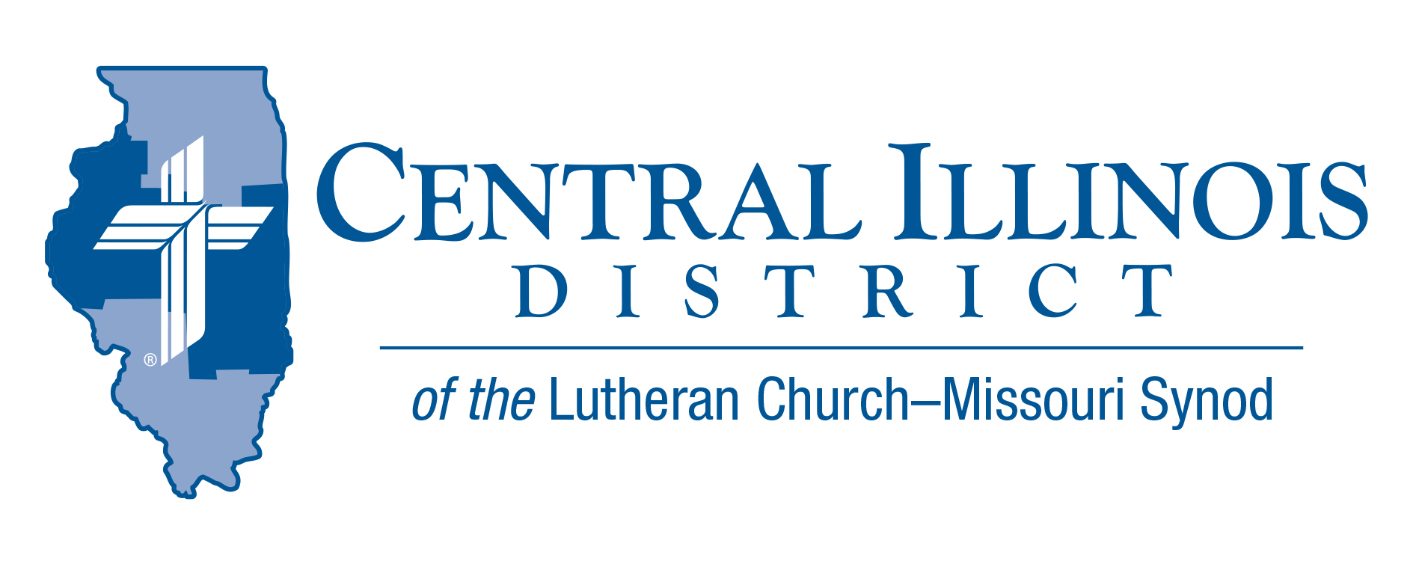
June 2025
News You Can Use
Pentecost

Sunday, June 8 is the day we celebrate Pentecost. Many will be wishing the Christian Church a Happy Birthday on this day. However, the Church are those called on by God to be his people. The Church is made up of those who have been given faith in the Lord Jesus Christ as the Savior of the world. All those who came before Christ and believed he would come are included in the Church. They include Adam and Eve, Abraham and Sarah, Moses, David, Elijah, Isaiah, and many more as indicated in Hebrews 11.

Truly, the Christian Church, those who believe in Christ, has existed from the beginning. Thus, Christianity is the oldest world religion and we give thanks to God for Pentecost, the day when the Spirit of God was given to the apostles, empowering them to boldly proclaim Christ and him crucified, fulfilling the promise of Christ to send the Comforter (John 16:7).

A blessed Pentecost to all.

Pastor Jeff Caithamer- St. John, Champaign

Pray For Our Central Illinois District Missions supported by your church’s Mission Dollars to the District.
Please remember in your prayers our District’s Lutheran Early Response Training (LERT) volunteers, who provide help in Jesus’ name to churches and individuals affected by natural disasters. Pray for the hundreds of LERT workers in CID and throughout our Synod.

Items of Interest to Share
“Reaching In” Prison Mentoring Program Coming to CID
You can help with prison ministry from outside a prison! “Reaching In,” a letter-writing mentoring ministry developed in southern Illinois, is now available in CID. Correspond with inmates via letters sent back and forth to a P.O. box, thus guarding your identity and location information. For more, e-mail your name and phone number to prisonministry@cidlcms,org An exhibit on prison/jail ministry will be at the CID convention, July 13-15.

CTSFW Protreptics: An Approach to Holy Conversation Outside
the Church. Dr. Chad Kendall (Normal, Illinois June 16–18, 2025)
This course will explore the work of Clement of Alexandria and his approach to
protreptics as he conversed and sought to persuade a variegated and syncretistic Alexandrian culture. This course will define this ancient approach called protreptics and will provide historical background to protreptics and allegory. It will examine second- and third-century Alexandria, providing an opportunity to understand Clement's teaching method. Our world today is looking more like Clement's Alexandria. This course will, then, suggest a protreptic approach to engage people today in the post-Christian world.
Location: Christ Lutheran Church in Normal, IL 61761
Schedule Class begins every day at 9:00 a.m. and ends the last day at 12:00 p.m.
Register by credit card: Contact LeeAnna Rondot at (260) 452-2204.
Register online: Go to ctsfw.edu/CE/Normal-Illinois.
CID BOARD OF DIRECTORS REVIEW REPORT 05/20/25
Opening devotion was given by Rev. Mike Burdick on Psalm 127.
Pastor Hull, campus ministry pastor at Western Illinois University, gave a Mission Presentation. He shared the blessings of his first year of service at Western, including four confirmations. Pastor Hull holds a weekly Bible class and hosts 6-8 students for supper. There are plans for monthly disputations on ethical topics in the upcoming academic year at Western, where Pastor Hull will have the opportunity to give a public confession and defense of Christianity.
President Mohr’s report included this year’s candidate placements from both seminaries. There were 145 requests for candidates with 92 candidates assigned, with 53 requests unfilled. 3 Candidates were placed into CID in addition to 1 deaconess.
A New CID Personnel Handbook was approved.
Revised constitutions were approved for St. John’s, Campaign; Christ, Clinton; Calvary, Watseka; and St. Paul’s, Woodworth.
A late Overture to Launch a Funding Campaign for Mission Support in the Central Illinois District was approved. Another late Overture to Establish a Date for District Convention was approved.
There will be a Zoom Board meeting to call a part-time District Mission Executive in early June 2025.
Convention News:
Central Illinois District LCMS 61st Regular Convention
Theme: “Witnessing Christ to the People” Acts 13:30-31
July 13-15, 2025
Crowne Plaza Hotel- Springfield, IL
The Convention Workbook has been posted to the CID website.
Here is the direct link to the 2025 CID Convention Workbook. https://www.cidlcms.org/Convention2025/2025.Workbook.pdf

