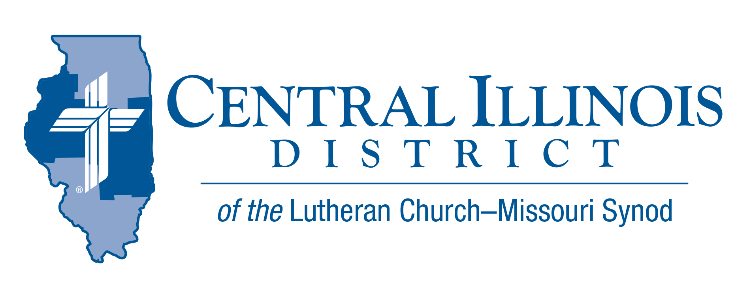
March 2025
News You Can Use
Lent starts late this year. We have been able to enjoy two full months of Epiphany, the revelation of the glorious power and grace of our God and Savior Jesus Christ. Remembering this lightens Lent’s dark themes of sin and its horrible consequences. Perhaps also the presence of sunlight as we exit our mid-seek Lenten services will help us to remember the blessed end of all this: God’s glorious grace shining on us out of an opened heaven.
While the presence of physical light can improve our moods, Jesus Christ, “the light of the world” (John 8:12), improves everything for God’s believing people. God’s word is a lamp for our feet and a light for our paths (Psalm 119:105). In Epiphany, Lent, Easter, and every week of the Church year, God’s word shows us His gracious love for us, because He did not leave us in the darkness, but “brought life and immortality to light through the Gospel” (2 Tim. 1:10). “Because the God who said, ‘Light shall shine out of darkness,’ is He who shined in our hearts for the enlightenment of the knowledge of the glory of God in the face of Jesus Christ” (2 Cor. 4:6). “Christ died for our sins according to the Scriptures … But now Christ has been raised from the dead, the first fruit of those who have fallen asleep … Thanks be to God, who gives us the victory through our Lord Jesus Christ” (1 Cor. 15:3,20,57). Enjoy a lighter Lent!

Pastor Mark Eddy, 1st Vice-President - CID Board of Directors

Pray For Our Central Illinois District Missions supported by your church’s Mission Dollars to the District. “Finally, brothers, pray that the Word of the Lord may spread rapidly and be honored.” Please remember in your prayers Pastor Pablo Dominguez and Cristo Rey (Christ the King) Lutheran Church in East Moline, where the ministry is conducted almost entirely in Spanish, as well as St. John’s Lutheran Church in Beardstown, where Pastor Dominguez travels twice a month to preach and teach in Spanish.

Items of Interest to Share

2025 LCMS YOUTH GATHERING
Registration is now open for our All-Illinois district event! The event will be on Sunday night at the Dome! It will be a meal, entertainment, t-shirts, giveaways, and seating on the floor for the mass event. This event will save you from having to make dinner plans for one night at the Gathering, and you get to go into one of the club areas in the dome!
The deadline to register for the All-Illinois district event is April 1st! Here is the link: https://www.cidlcms.org/2025nyg.html

Ministry Outreach Grants – 2025 Round 1
Just a reminder to submit your requests for the first round of Ministry Outreach grants from the Central Illinois District Church Extension Fund (CID-CEF)! Submissions should be received by April 1. These grants are provided to assist our congregations, agencies, and individuals in carrying out the mission and ministry of the LCMS, with special consideration given to new and innovative opportunities addressing the issues and concerns confronting our District and its congregations.
The application for the grant can be found on our website at www.cid-cef.org, then look under “Grants” and “Ministry Outreach Grants.” You can also email us at cef@cidlcms.org or call our office at 217-793-1802 to obtain a copy of the application. The deadline is April 1, 2025.
LWML CID District Convention: April 25-26, 2025, at Zion, Lincoln, IL.
Friday, the 25th, we will have servant events, an evening meal followed by worship service and fellowship hour at Zion Church.

Saturday, the 26th, is convention day at Zion School. We are thrilled to have Old Missionary Gary Thies of Mission Central as a keynote speaker. Also, we are equally happy that LWML President Eden Keefe will be with us. Delegates will tend to the district's business and select mission grants for funding. Six Breakout sessions will be held. Registration and hotel information will be available from your church’s LWML group or at https://lwmlcid.org beginning March 10th.

2025 Illinois Pro-Life March is scheduled for March 25th in Springfield
On March 25, 2025, concerned citizens from all over Illinois will gather in Springfield for the annual state Pro-Life March. Appropriately, March 25 is the festival of the Annunciation. Annunciation Day will make an excellent occasion for the Pro-Life March.

Trinity Lutheran Church (220 S 2nd St, Springfield, IL, 62701), across the street from the state capitol building, will again conduct a Matins service at 11:00 a.m. Northern Illinois District President Allan Buss will preach. Immediately thereafter, worshipers may walk to the ballroom of the State House Inn, one block north of the capitol building, to pick up a light lunch consisting of a four-inch ham or turkey sandwich, bag of chips, cookie, and bottle of water. The suggested donation is $6. The Pro-Life rally outside the capitol is scheduled to begin at 1:00 p.m. Actual marching should step off at about 2:00 p.m. Worshipers may park in the State House Inn’s west parking lot at the corner of Adams and First Streets.

CID Convention Reminders:
- Convention Date: July 13-15, 2025- Springfield, IL
- Floor Committee meeting date: March 15th

