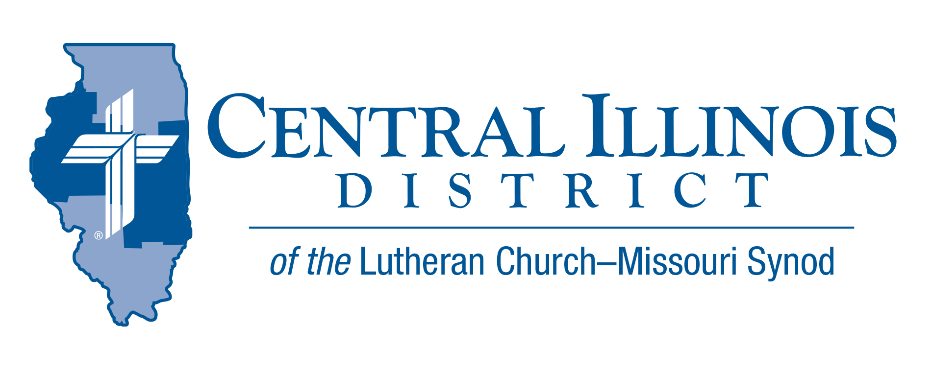
May 2025 mid-month
News You Can Use
A.D.D.
It is a terrible problem, affecting many more people than maybe you would guess: A.D.D. Yes, I mean Ascension Deficit Disorder.
A.D.D. strikes when we imagine that Christ and His blessings are long ago and/or far away. When the world pressures us, we grow troubled. When our sins come crashing back into our minds, we become terrified. Even when loved ones die in the Lord, we might see no end to our grief.
In fact, we get stuck on what we see. When our horizon shrinks and it’s as if we have hoped in Christ for this life only, it’s pitiful. This A.D.D. is a scourge!
There is an answer for it, namely, the real ascension of our Lord. “He put all things under his feet and gave him as head over all things to the church, which is his body, the fullness of him who fills all in all” (Eph. 1:22-23).
Celebrate Christ’s ascension on May 29!
Dr. Ken Schurb – CID office

Pray For Our Central Illinois District Missions supported by your church’s Mission Dollars to the District.
Please remember in your prayers all our CID campus ministries, especially Rev. Michael Schuermann and University Lutheran Church in Champaign, serving students, faculty, and staff of the University of Illinois and other institutions. And pray for the “Keeping Christ on Campus” campaign, building endowments to help CID support our campus ministries.

Items of Interest to Share
National Youth Gathering -WAYS TO CONNECT
- CID Lutheran Youth Facebook Group – Latest District updates and information www.facebook.com/groups/249327678480252
- LCMS Youth Ministry Facebook Group – Gathering related content and collaboration, but all things youth ministry, too! www.facebook.com/groups/LCMSYouthMinistry
- National Youth Gathering Website – Tons of information, worksheets, budgeting sheets, etc. www.lcmsgathering.com

Small Church Summit – Opening devotion 9:30 a.m. on Sat., June 7, 2025 at
Trinity Lutheran Church,
1010 N. Webster Street, Taylorville, IL 62568-1277
The deadline to register is May 31.
Featured presenter is The Rev. Dr. Alexey Streltsov, Rector of our sister church’s seminary in Siberia. He will tell us how small churches operate in his part of the world. How often do we get the opportunity to learn about the way our sister congregations work there? Rector Streltsov will take the morning to make his presentation and answer initial questions.
After lunch, there will be several short sectional sessions, all of which will be offered a total of twice:
1. Further discussion with Rector Streltsov
2. Congregational Assessment Tools
3. LCMS Specific Ministry Pastor Program and Small Congregations
4. Mutual Help Right Under Your Nose: Circuit Forums & Convocations
The day’s activities will conclude with an Ice Cream Social after adjournment at 3:00 p.m.
To register for the Small Church Summit, go to https://forms.gle/2odPUnCrW66hpf9o6 Deadline is May 31!
The Small Church Summit is free. If you think your church is small, you’re invited. And all are welcome! We hope to see YOU on June 7!

Convention News:
Central Illinois District LCMS 61st Regular Convention
Theme: “Witnessing Christ to the People” Acts 13:30-31
July 13-15, 2025
Crowne Plaza Hotel- Springfield, IL

The Convention Workbook has been posted to the CID website.
It contains all District reports and convention information, including the resolutions that will be presented at the convention.
Here is the direct link to the 2025 CID Convention Workbook. https://www.cidlcms.org/Convention2025/2025.Workbook.pdf

Ministry Readiness Study Report

The Lutheran Church Extension Fund—Missouri Synod, has recently completed a Ministry Readiness study for CID, to determine the District's capacity to undertake a financial campaign.

Based on this study, LCEF recommends that CID pursue such a campaign. A three-year, $3 million campaign is being contemplated. Please pray for this effort and for the delegates to this summer’s convention who will consider launching this endeavor!

We urge you to examine a summary of the study’s findings and discuss this possible campaign with your fellow church members and your congregation’s delegates to the District convention. You can review this summary and other related information in the “Mission Education Toolkit” on the CID website at https://www.cidlcms.org/ministry-stewardship.html

