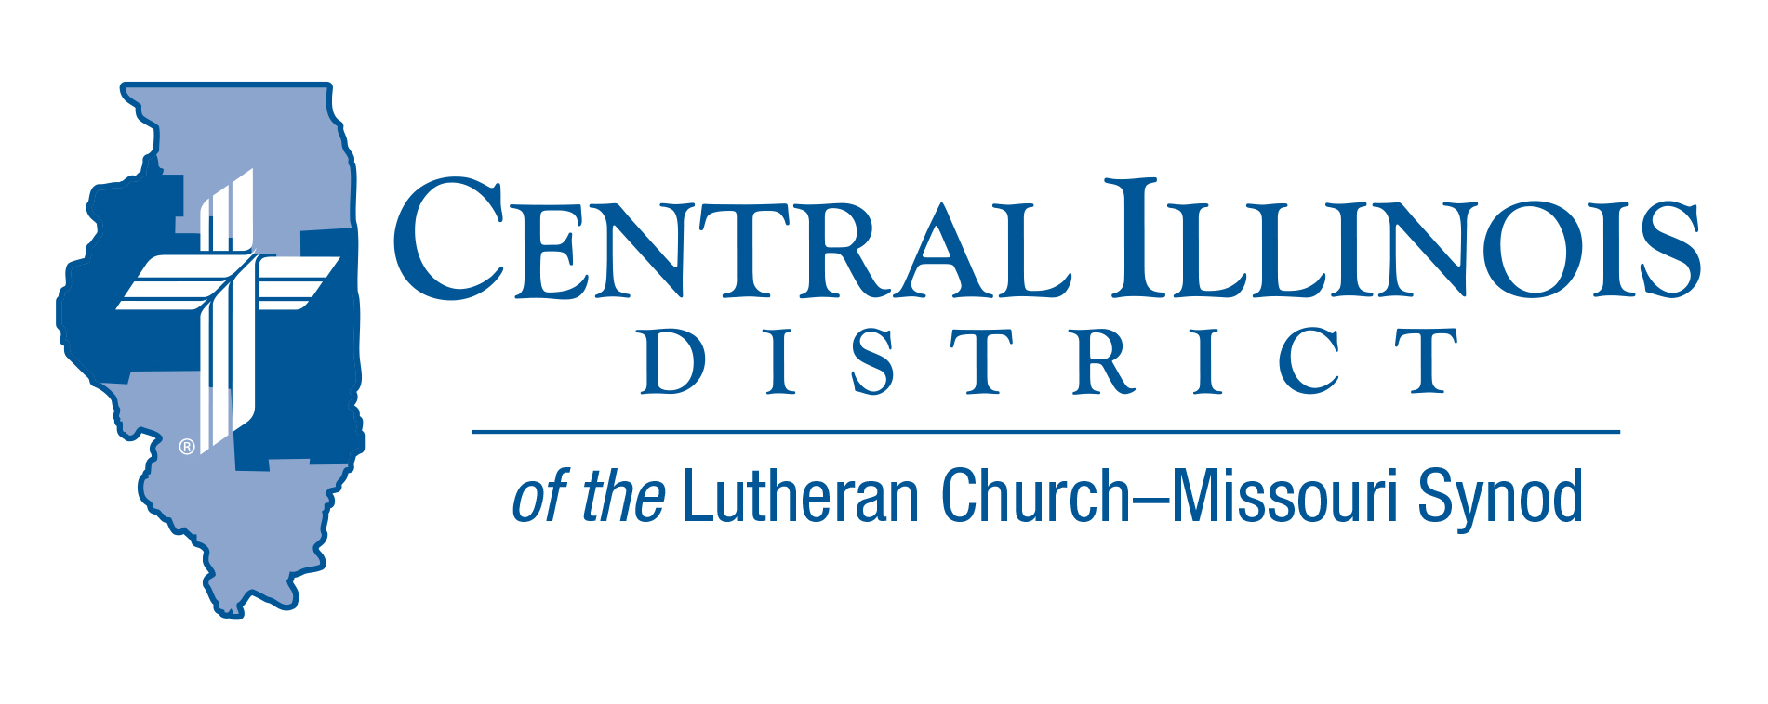
November 2025
News You Can Use

As the days grow shorter and the air turns colder, November brings with it a natural pause. The calendar year is winding down and so is the church year, which ends with a final, resounding reminder: Christ still rules over all.
Psalm 95 gives us this invitation: “Oh come, let us sing to the Lord; let us make a joyful noise to the rock of our salvation! Let us come into his presence with thanksgiving; let us make a joyful noise to him with songs of praise!
God invites us to enter His presence with thanksgiving, not out of duty, but out of joy. Not because everything has gone right, but because God remains faithful. He is still the rock of your salvation. He still rules over all.
So whether with a full heart or a weary one, come into His presence. He welcomes your song. He receives your thanks. And His grace and mercy endures, now and forever.

Pastor Patrick Gumz – Central IL District Missions

Pray For Our Central Illinois District Missions, supported by your church’s Mission Dollars to the District.
Please remember in your prayers all our CID campus ministries, especially Rev. William Jensen and Wittenberg Lutheran Center in Normal, serving students, faculty, and staff of Illinois State University and other institutions. And pray for the “Keeping Christ on Campus” campaign, building endowments to help CID support our campus ministries.

Items of Interest to Share
The Small Church Summit for Winter, 2026, will feature a presentation by SID President Heath Curtis titled “The Small Town Lutheran Church.” Sectionals will be on “Shepherding our Strays,” technology in small churches, and safety standards. Saturdays in two locations:
- Hope Lutheran Church, Highland – on Jan. 10 or (if weather is bad then) Jan. 31
- St. Paul Lutheran Church, Lexington – on Feb. 7 or (if weather is bad then) Feb. 21
Sign-in will be at 9:30 a.m., opening devotion will commence at 10:00, and closing prayer will be at 2:30 p.m. Register by January 3, 2026 at https://forms.gle/eujwE5hmRC48wF7MA
If you think your church is small, YOU are invited. And everyone is welcome!

Current Dollar For Mission Project
Project: Replace original kitchen equipment in the sexton's apartment at Immanuel Lutheran Student Center, Macomb
Immanuel Lutheran Student Center in Macomb was dedicated in 1969, but some kitchen equipment in the apartment for the live-in student who takes care of the student center (the sexton) has not been replaced since then. DFM funds would be used to replace the original kitchen equipment.
Amount to be funded: $11,000.00
MUSIC FOR MISSIONS – St. John's Lutheran Church (711 Court Street) in Pekin is hosting a Sacred Music Concert and Hymn Sing in support of our Immanuel Lutheran Student Center, our LC-MS Central Illinois District Campus Ministry at Western Illinois University, Macomb, on Sunday, November 16, 2025 at 2:00 p.m.

We will join together in singing some hymns, and in listening to sacred organ, choir, vocal solo, and handbell music, all under the theme, “Hymns of Our Heavenly Home.” Featured musicians will include guest organist Peter Wykert, vocalists Allison Harley and Jennifer Rosa, as well as the St. John's Hand Bell and Sanctuary Choirs.

A free-will offering will be gathered to support our Immanuel Lutheran Student Center in Macomb (under the leadership of Pastor Chris Hull). Refreshments will be served following the program.

Please set aside the time to participate in and enjoy the music program, and to support our Central Illinois District mission work. For more information, you may contact the church office at 309-347-213.

2026 Youth Bible Bowl
Date: Will be in the spring of 2026. We are still working on the date.
Topic: "The Gospel According to St. Matthew"

The Gospel according to St. Matthew gives a summary of what we need to know in order to have salvation from sin, the devil, and death. St. Matthew's Gospel records the most important teachings of Jesus and the key events in Jesus’ life. Plan to study "the Gospel according to St. Matthew" with youth (junior and senior high [grades 6-12]) as thoroughly as you can, to prepare them to answer questions in your Circuit and at the District Bible Bowl in the spring, and (most importantly) so that by God’s grace and the power of the Holy Spirit they grow in their faith that Jesus truly is the Son of God and our Savior.
Contact Rev Mark Eddy (zionlcms@juno.com) for additional information.

Central Illinois Church Extension Fund Investment Rate
at 3.75% for 11 Months!
Even though the Federal Reserve just cut
interest rates, the CID-CEF is still offering its 11-month investment at 3.75%. This is a limited-time offer, so please take advantage of this opportunity to assist our churches and schools in financing the expansion of their ministries. At the same time, you receive the added blessing of a great interest rate!

