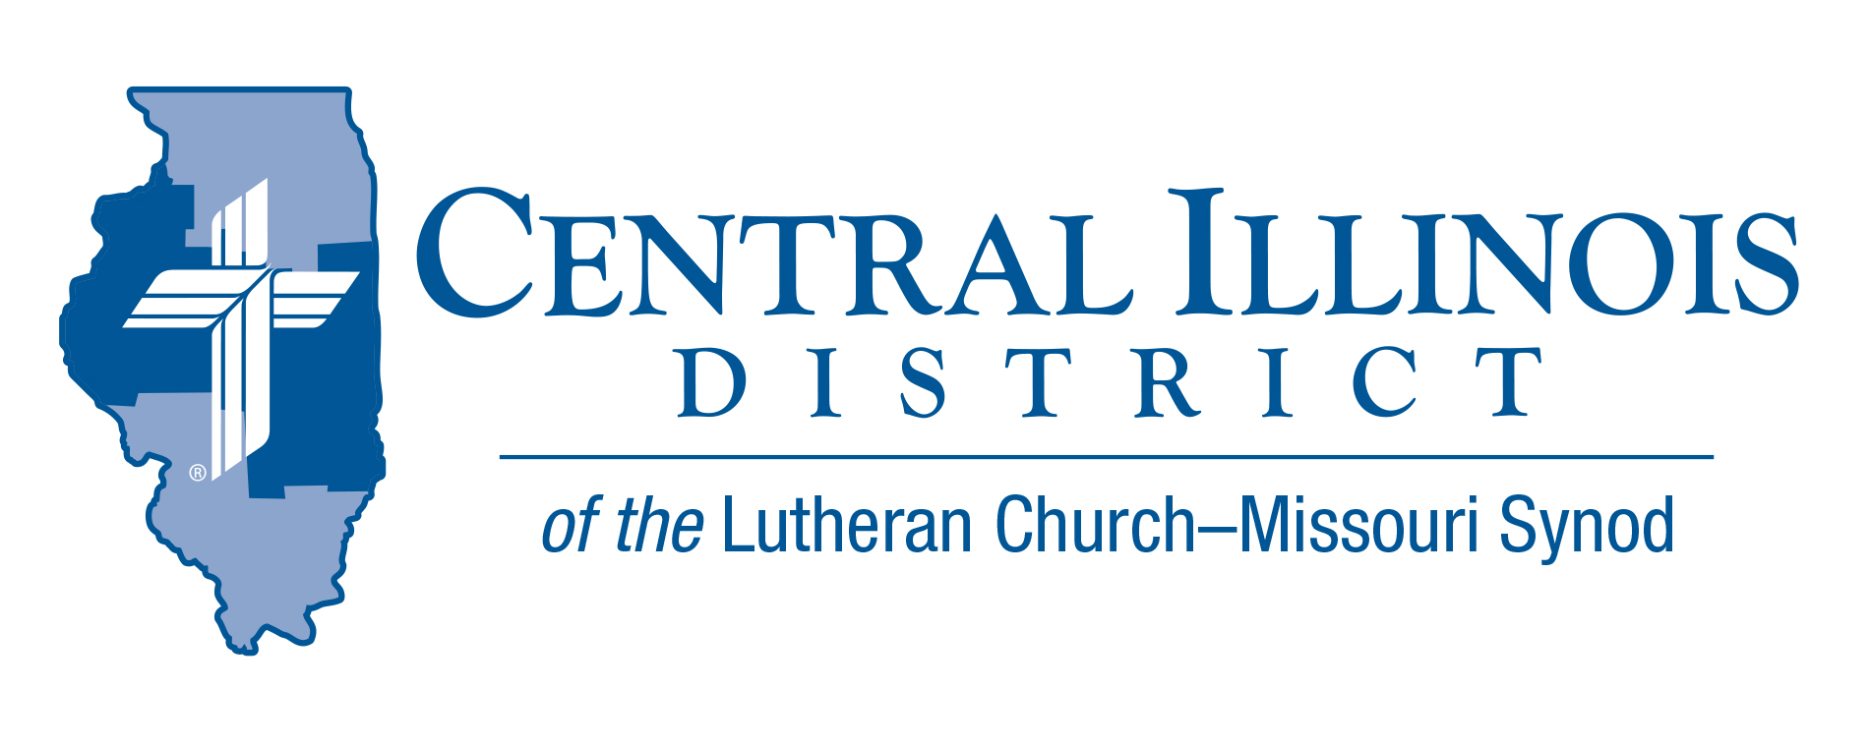
October 2025 mid-month
News You Can Use

I, I am he who blots out your transgressions for my own sake, and I will not remember your sins. Isaiah 43:25
Due to advancing age, illness, or other maladies many of us struggle to remember things. It can be very frustrating! I forget where I put my keys or my cell phone. And I quickly forget names. Yet I have trouble forgetting some things, like something a person says or does that offends me. And I may ruminate for days about my sins or mistakes.
The inability to forget some things and to remember others is a weakness with us. But God has the amazing ability to forget what he does not want to remember. And he always remembers what he doesn’t want to forget. He remembers his promises and his love for us. When he says, “I forgive you” he immediately forgets the sin and wipes it from his mind as if it never happened. This is an amazing strength that is beyond our comprehension!
Satan tempts us to doubt God’s word and to mistrust his promises. He wants us to believe his lie that God holds grudges and bears resentment. Satan wants us to argue with God by condemning ourselves or others for sins that have been absolved and that He has chosen to forget. We must always remember the verse above. Romans 8:1-2 reminds us , Therefore, there is now no condemnation for those who are in Christ Jesus, because through Christ Jesus the law of the Spirit of life set me free from the law of sin and death.
When our pastor pronounces Christ’s absolution and when we confess our sins in Christ to one another, we are set free from condemnation and the fear of punishment! Satan cannot condemn us, and our guilty consciences and resentful hearts are silenced by Christ’s true and holy Word! As Jesus said in John 8:32, you will know the truth and the truth will set you free!

Rev Jeff Harter

Pray For Our Central Illinois District Missions supported by your church’s Mission Dollars to the District.
Please remember in your prayers Central Illinois Lutheran Deaf Outreach, CID’s District-wide parish, conducting Word and Sacrament ministry in American Sign Language to bring the Good News about Jesus to the deaf and hearing-impaired. Most deaf people are non-churched. They need Christ!

Items of Interest to Share
CID Junior High Youth Event – Save the Date
Theme: “Make A Joyful Noise”
Saturday, November 8th, 2025, at Camp Cilca
Time 9 am – 4 pm (sign-in will start at 8:30 am)
Cost $40 per youth --- $0 for adult leaders
(includes lunch, t-shirt, and a full day of activities)

Start planning now to attend this Junior High Youth Event. Registration, long-sleeve t-shirt orders, and additional information will be found at the following link: https://forms.gle/KaSiitVeioUgLBQU9

Deadline for registration is October 20th. After that date, individuals can still register up to October 30th, but will not receive a t-shirt.

MUSIC FOR MISSIONS – St. John's Lutheran Church (711 Court Street) in Pekin is hosting a Sacred Music Concert and Hymn Sing in support of our Immanuel Lutheran Student Center, our LC-MS Central Illinois District Campus Ministry at Western Illinois University, Macomb, on Sunday, November 16, 2025 at 2:00 p.m.

We will join together in singing some hymns, and in listening to sacred organ, choir, vocal solo, and handbell music, all under the theme, “Hymns of Our Heavenly Home.” Featured musicians will include guest organist Peter Wykert, vocalists Allison Harley and Jennifer Rosa, as well as the St. John's Hand Bell and Sanctuary Choirs.

A free-will offering will be gathered to support our Immanuel Lutheran Student Center in Macomb (under the leadership of Pastor Chris Hull). Refreshments will be served following the program.

Please set aside the time to participate in and enjoy the music program, and to support our Central Illinois District mission work. For more information, you may contact the church office at 309-347-213.

2026 Youth Bible Bowl
Date: Will be in the spring of 2026. We are still working on the date.
Topic: "The Gospel According to St. Matthew"

The Gospel according to St. Matthew gives a summary of what we need to know in order to have salvation from sin, the devil, and death. St. Matthew's Gospel records the most important teachings of Jesus and the key events in Jesus’ life. Plan to study "the Gospel according to St. Matthew" with youth (junior and senior high [grades 6-12]) as thoroughly as you can, to prepare them to answer questions in your Circuit and at the District Bible Bowl in the spring, and (most importantly) so that by God’s grace and the power of the Holy Spirit they grow in their faith that Jesus truly is the Son of God and our Savior.
Contact Rev Mark Eddy (zionlcms@juno.com) for additional information.

