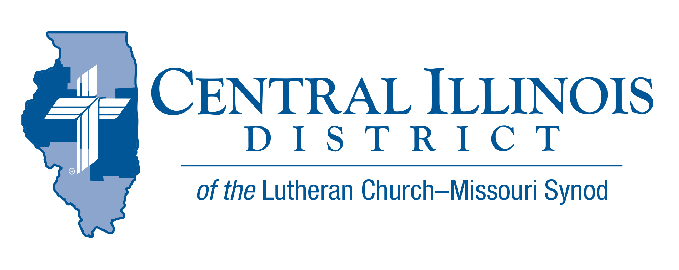
April 2026
News You Can Use

As the days of spring continue to lengthen and the sun creeps higher in the sky a little more each day, the joy of Good Friday and Easter can’t be matched. We celebrate the heart of the faith with the triumphant words from the ancient hymn “At the Lamb’s High Feast We Sing” (LSB 633:7): “Easter triumph, Easter joy!”

Christ is risen! Alleluia! Jesus kicked death in the teeth, shattering its power forever and flinging wide the gates of eternal life. Because Christ lives, we shall live also [John 14:19]. “Now in Christ, death cannot slay me” (LSB 756:5). Martin Luther writes: “We should learn to view our death in the right light… because in Christ it is indeed not death, but a fine, sweet and brief sleep… until the time when He shall call and awaken us together with all his dear children to his eternal glory and joy… we shall… suddenly come alive out of the grave” (from A Compend of Luther’s Theology, ed. Hugh T. Kerr, Jr., p. 242).
Rev. Dr. Timothy J. Fitzner, Pastor-- Christ Lutheran Church, Normal

Pray For Our Central Illinois District Missions, supported by your church’s Mission Dollars to the District. Please remember in your prayers Immanuel Lutheran Chapel, a new church start by Immanuel Lutheran Church, Springfield. Pastor Adam Rouse serves both Immanuel church on Springfield’s northeast side and the chapel on the northwest side at the CID office.

Executive Director Position Opening - LCMS District Church Extension Fund
Have you ever felt like your work could be more gratifying? That you’re devoting all your time and effort to a business that doesn’t match your values or that is constantly striving for new goals without meaning? That you could be devoting your skills to a better and higher cause?

If these questions give you pause, please give prayerful consideration to applying for the position of Executive Director of the Central Illinois District Church Extension Fund (CID-CEF), a stand-alone not-for-profit corporation located in Springfield, Illinois. This position will give new meaning to your work life as you devote your time and effort to the Mission of growing God’s Kingdom by extending loans and grants to the churches, schools, and agencies that reside within the Central Illinois District.

You will have responsibility for the administration, management, and operations of the CID-CEF under the direction of their Board of Trustees, which are comprised of pastors, bankers, and lay people from the LCMS within the District. Your responsibilities will include all loaning functions, internal investment operations, external investment of funds, financial reporting, marketing, policy, legal, and insurance requirements, in accordance with sound business practices but with primary responsibility to the service and support of our churches and schools.

Qualifications for this position include a Bachelor’s degree in Business, Accounting, or Finance, with six to ten years of progressive management experience in a related financial environment.

If you would like a new perspective on work and a more satisfying and fulfilling career where your efforts will benefit a higher cause, please contact Darin Gehrke at 217-883-1247 or Kevin Schultz at 217-341-8622 for a full job description and qualifications.

LWML DISTRICT CONVENTION
The 81st Annual Convention of the Central Illinois District Lutheran Women’s Missionary League (LWML) will be held Saturday, April 25th at St. Paul’s Lutheran Church, 1 Bachrach Dr., Decatur. The theme, ‘For the Lord will be your Everlasting Light, is based on Isaiah 60:20. Martha Dahlke, LCMS Mission Advancement, will be our speaker. Linda Guteres, VP Communication, will be the LWML representative. Servant events and an evening worship service will begin on Friday afternoon at 1 pm on April 24th. These will be held at St. John’s Lutheran Church, 2727 N Union St., Decatur. On Saturday, our convention will include the above-named speakers, breakout sessions, important business items, and wonderful fellowship with each other. Additional invitation information may be found at www.lwml.org or from your local group.

2026 Youth Bible Bowl. Central Illinois District Bible Bowl
On March 22, seven Bible Bowl teams competed in the 2026 District-wide Bible Bowl at Camp CILCA. We had teams from Immanuel-Macomb, St. Paul-Wheeler, Mt. Calvary, Galesburg (A/B), St. John, Effingham, Bethlehem, Altamont, and Faith, Sullivan. This year’s theme was based on the book of Matthew. This year’s winner was Faith-Sullivan (Will, Nathan, and Ben). 2nd place was Mt. Calvary (A) (David, Natalie, Olie, and Daniel). Thanks to President Eddy and Pastor Theilen for their assistance with the Bible Bowl.
Next year, our topic will be from the Old Testament. The topic and date of the spring Bible Bowl will be announced in the fall. If you are interested in receiving information about forming a Bible Bowl team, please reach out to the district office (Cid@Cidlcms.org).


Dollars for Mission Online Project: A new lighted, cast aluminum sign for Wittenberg Lutheran Center at Illinois State University
The second 2026 project for Dollars for Mission is a new lighted sign for Wittenberg Lutheran Center. $7,000 will be collected for the cost. The cast-aluminum sign will feature the Wittenberg logo and be placed on the building's steeple to proclaim the work of Christ and the Holy Spirit for all.
Amount to be funded: $7,000
Reminder that online one-time and recurring donations can now be made at
https://www.aplos.com/aws/give/LCMSCentralIllinoisDistrict/D4M
or by using the QR code.

