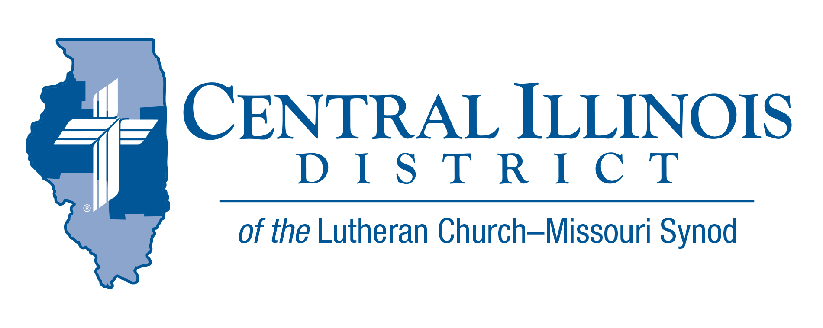
February 2026 – Mid-month
News You Can Use

District Leadership Update
Central Illinois District Board of Directors – Special Meeting (Feb. 2, 2026)
At a special meeting on February 2, the Board of Directors appointed Pastor Mark Eddy to serve as Acting District President of the Central Illinois District.
While this is not “business as usual,” the work of the District continues. God remains faithful, and through His Word and Spirit, and through the people of our District and Synod, He continues to carry out His work among us.

What Has Not Changed
God: Father, Son, and Holy Spirit
No change. God continues to provide for our needs of body and soul and freely gives forgiveness of sins, life, and salvation through Christ.
Head of the Church: Jesus Christ
No change. Christ crucified and risen continues to be proclaimed in our congregations, supported by the shared work of the District, circuits, and Synod.
District Leadership & Support
Acting District President: Mark Eddy
Pastor Eddy serves under Christ to be His ears, eyes, and mouth to hear your concerns and questions, to see others in the light of God’s mercy and grace, and to speak clearly and faithfully the unchanging Gospel to the hurting and distressed.
First Vice President: Jason Braaten
With experience as a parish pastor and service to the wider district and Synod, Pastor Braaten continues to assist with the responsibilities assigned as a board leader.
Education & Congregational Life – Trip Rodgers
Continues to support congregations and schools through education leadership, congregational life resources, and district communication.
Evangelism – Rev. Dr. Ken Schurb
Continues to provide evangelism resources, consultation, and support for congregations and circuits.
Missions & Business Management – Rev. Patrick Gumz
Oversees district mission work, campus and specialized ministries, financial and business operations, and administrative systems supporting congregations and leaders.
Pray For Our Central Illinois District
Please remember in your prayers all of our CID leaders & ministries, as well as all 148 congregations and the pastors who serve them with God’s gracious gifts.

2026 Youth Bible Bowl
Date: Sunday, March 22, 2026
Location: Camp CILCA
Topic: "The Gospel According to St. Matthew"

Those holding either a circuit Bible bowl, or with team(s) planning for the District Bible Bowl, please contact Trip Rodgers (trodgers@cidlcms.org) a.s.a.p. so we know how many to plan for. Thanks.

The Small Church Summit
St. Paul Lutheran Church, 1076 E Chatham Street Lexington, IL
Feb.21 or (Snow Date) Feb. 28
Register by February 13th, 2026 at https://forms.gle/eujwE5hmRC48wF7MA


Dollars for Mission Online
Our first project for 2026 is support for Hispanic Ministry in Beardstown, IL. $1800 will be collected to support travel costs for Rev. Pablo Dominguez. Reminder that online one-time and recurring donations can now be made at
https://www.aplos.com/aws/give/LCMSCentralIllinoisDistrict/D4M
or by using the QR code.

CAMP CILCA NEWS:
Camp CILCA -WOMEN RETREAT,
- March 6-7, 2026
- Calling all ladies! Our retreat theme is Pew Sisters: gather and celebrate our true sisterhood—our pew sisterhood!
- Guest Speaker: Mrs. Katie Schuermann
Two choices for our retreat...
- You can join us overnight for $100 and stay in the
Christian Growth Center.
- Want to stay at home, but still want to come to the
conference? There is a commuter option for $75.
Registration https://www.cilca.org/womens-retreat.html

CAMP CILCA SPRING WORK DAY & PANCAKE DINNER:
- March 14
- 8 am – 11 am: Help get the campground ready for spring and summer fun!
- 11 am – 1 pm Free pancakes for all!
Early Bird Registration Deadline for Summer Program at Camp CILCA is March 31

