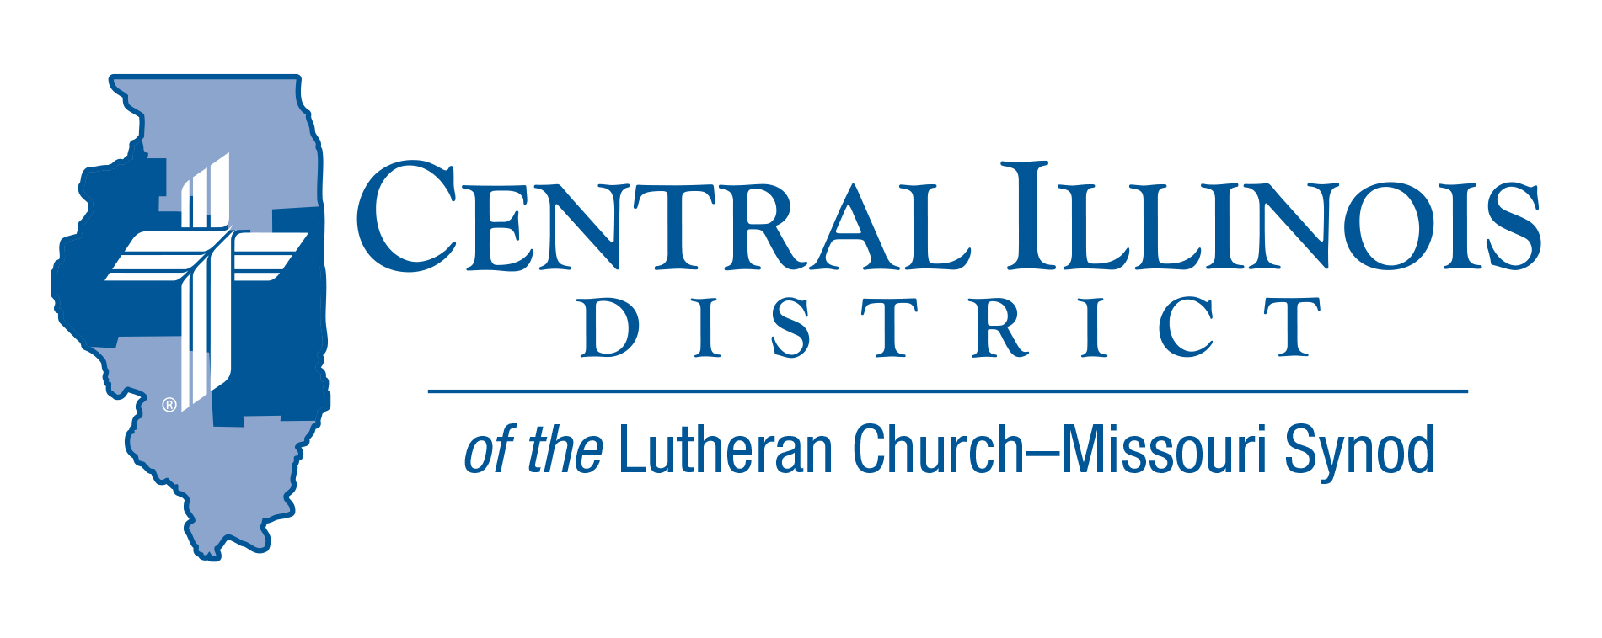
January 2026
News You Can Use

One of our shut-ins told me of the new tv documentary “The First Christmas,” hosted by Kevin Costner. Her advice for her granddaughter had been that the great-grandchildren not be allowed to watch it. She was right. In it, Herod was accurately depicted as darkly evil, and kids shouldn’t experience the depth of his twistedness yet.
While kids should be shielded from strong images of evil -- please protect them, mom and dad by carefully filtering what they watch -- adults ought to admit just how horrible the human mind and heart can be. Then lament and repent daily.
Jesus entered into a culture and creation infected with sin, to be the world’s Savior. To give us unlimited joy. Life in the midst of a State which has allowed physician-assisted suicide. Help in the midst of suffering. Deep peace. Forgiveness of sin. Confidence in the face of the grave. Light in the darkness. Hope in the midst of Herods.
“The Light shines in the darkness, and the darkness has not overcome it.” (John 1:5)
Christ the King reigns, no matter what the Herods of the world try to do. Rejoice.
- Pastor Mike Burdick St. John’s Lutheran Church, Effingham
Pray For Our Central Illinois District Missions, supported by your church’s Mission Dollars to the District.
Dear Father, we pray Thee, give us Thy Word, that the Gospel may be sincerely preached throughout the world and that it may be received by faith and may work and live in us. So we pray that Thy kingdom may prevail among us through the Word and the power of the Holy Spirit, that the devil’s kingdom may be overthrown and he may have no right or power over us, until finally the devil’s kingdom shall be utterly destroyed and sin, death, and hell exterminated, and that we may live forever in perfect righteousness and blessedness (from Luther’s Large Catechism).

Items of Interest to Share

Invest at 3.75% for 11 Months & Help Finance Churches and Schools!
The Central Illinois District Church Extension Fund (CID-CEF) Board of Trustees has extended the opportunity to invest in our special 11-month investment at 3.75%. This is a high interest rate for this length of term and won’t be around much longer, so please take advantage of this opportunity to assist our churches and schools in financing the expansion of their ministries while you receive the added blessing of a great interest rate!

Current Dollar For Mission Project
Project: Replace original kitchen equipment in the sexton's apartment at Immanuel Lutheran Student Center, Macomb
Immanuel Lutheran Student Center in Macomb was dedicated in 1969, but some kitchen equipment in the apartment for the live-in student who cares for the student center (the sexton) has not been replaced since then. DFM funds would be used to replace the original kitchen equipment. Amount to be funded: $11,000.00


Dollars for Mission Online – New this year, you can now support Dollars for Mission through online giving. Many people no longer carry cash but still want to support the Central Illinois District’s mission work. One-time and recurring donations are now available online at
https://www.aplos.com/aws/give/LCMSCentralIllinoisDistrict/D4M
or by using the QR code.

All new recurring gifts will be matched by
a special one-time gift, up to $20,000.

2026 Youth Bible Bowl
Date: March 2026 (working on March 21-22)
Location: Camp CILCA
Topic: "The Gospel According to St. Matthew"

The Gospel according to St. Matthew summarizes what we need to know to receive salvation from sin, the devil, and death. The Gospel of St. Matthew records the most important teachings of Jesus and the key events in Jesus’ life. Plan to study "the Gospel according to St. Matthew" with youth (junior and senior high [grades 6-12]) as thoroughly as you can, to prepare them to answer questions in your Circuit and at the District Bible Bowl in the spring, and (most importantly) so that by God’s grace and the power of the Holy Spirit they grow in their faith that Jesus truly is the Son of God and our Savior.

Contact Rev Mark Eddy (zionlcms@juno.com) for additional information.

The Small Church Summit for Winter, 2026, will feature a presentation by SID President Heath Curtis titled “The Small Town Lutheran Church.” Sectionals will be on “Shepherding our Strays,” technology in small churches, and safety standards.

St. Paul Lutheran Church, 1076 E Chatham Street, Lexington
Feb.21 or (if weather is bad) Feb. 28

Sign-in will be at 9:30 a.m., opening devotion will commence at 10:00, and closing prayer will be at 2:30 p.m. Register by February 13th, 2026, at https://forms.gle/eujwE5hmRC48wF7MA
If you think your church is small, YOU are invited.
And everyone is welcome!

