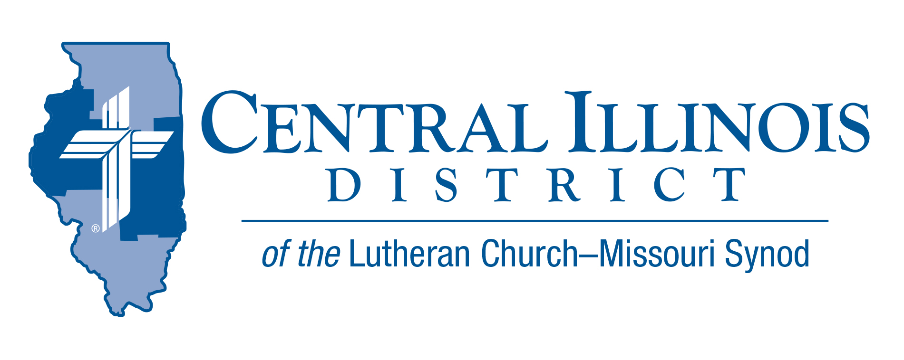
June 2026
News You Can Use
What’s New?
“What has been is what will be, and what has been done is what will be done, and there is nothing new under the sun.” -Ecclesiastes 1:9

Solomon, son of David, is not pontificating on the return of warmer temperatures “under the sun.” He’s observing that man and creation in all their might cannot evolve into something new. Our technology is only “newish” for a while, but it doesn’t last. Despite all the world’s media to get you to subscribe to what it’s offering; it has nothing new. Even a pastor who’s outed publicly as a sinner is old news.
The new life Jesus brings isn’t subject to a changing calendar under the sun. Who Jesus is and what He does is new because it’s everlasting. His Gospel and life are true and new for eternity. His conception and birth in Mary’s womb are not an evolution of man but the revelation of God becoming man and forever making man new in Him. He’s lifted up on the cross as the new Son of David. Risen from the dead, His hands and side bear testimony that even His forgiveness for us is always new. He’s coming back to make all things new (Rev. 21:5).
The baptismal life He gives renews you in Christ. The body and blood He gives you has already broken forth from the grave as the New Testament. Living in faith, we have good news for Solomon or anyone who’s under the sun. If you’re tired of the same old, God, who comes to us in word and sacrament from above the sun, is, was, and ever shall be new.

Rev. Marcus Manley

Pray for Our Central Illinois District Missions, supported by your church’s Mission Dollars to the District.
Please remember in your prayers our District’s Lutheran Early Response Training (LERT) volunteers, who provide help in Jesus’ name to churches and individuals affected by natural disasters. Pray for the hundreds of LERT workers in CID and throughout our Synod.

Summer Small Church Summit- Reminder
- Saturday, June 13
- at Trinity Lutheran Church, 1201 W Jackson St, Auburn, IL

CID BOARD OF DIRECTORS REVIEW REPORT 05/26/26
An opening devotion was led by Vice President Braaten on verses from 1 Chronicles 12.
Pastor Michael Schuermann gave a Mission Report on behalf of UniLu. Dr. Scot Breitenfeld was nominated to serve on the LC-MS Commission on Constitutional Matters. Rev. Dan Bishop was nominated to serve as CID District Reconciler. Kerry Bell was nominated to serve on the LC-MS Foundation Board of Trustees.
Mrs. Christine Anderson was thanked for her 8 years of service as the Executive Director of our Central Illinois District Church Extension Fund and presented with a gift by President Eddy. Mr. Joel Oschwald has been selected as the next Executive Director of CID-CEF.
The board of directors returned to the historic practice of the 1st vice president, Rev. Jason Braaten, serving as chairman, and the 2nd vice president, Rev. Karl Eckoff, serving as chaplain of the board.
The board established the position of Executive Assistant to the District President.
The board authorized CID Business Manager Gumz to sell Christ Lutheran Church of the Deaf in Jacksonville for any amount over $70,000.
Next CID Board of Directors Meeting scheduled for Sept. 22, 2026.

The Concordia Chicago Festival of Scripture & The Arts will take place on campus (Concordia University -River Forests, IL) this month, June 20–21. The two-day event, inspired by the Song of Solomon, will feature a variety of lectures, presentations, performances, and a special commissioned artwork.
The festival’s highlight is the premiere performance of “Song of All Songs,” a new work by Professor of Music Dr. Jonathan Stahlke. The piece draws on the entire biblical text of the Song of Solomon and will be performed by an orchestra, two choirs, and vocal soloists.
We would love to welcome members of your congregations and communities to join us for the full festival or simply for the Sunday concert. Tickets for the full two-day festival are available on our website at https://www.cuchicago.edu/events/2026/062/festival-of-scripture--the-arts--song-of-all-songs/. The Sunday concert remains completely free and open to the public. Our hope is to include as many people as possible in this celebration of Scripture, creativity, and fellowship!

For more information, call 217-242-8948.

Welcome Joel Oschwald to the CID-CEF!

Joel Oschwald has joined the Central Illinois District Church Extension Fund as the new Executive Director, succeeding Christine Anderson upon her retirement on July 31. Joel brings a wealth of banking experience to the Church Extension Fund, complemented by a Master of Divinity from Concordia Theological Seminary. Please join us in welcoming Joel to his new position at the CID-CEF!

