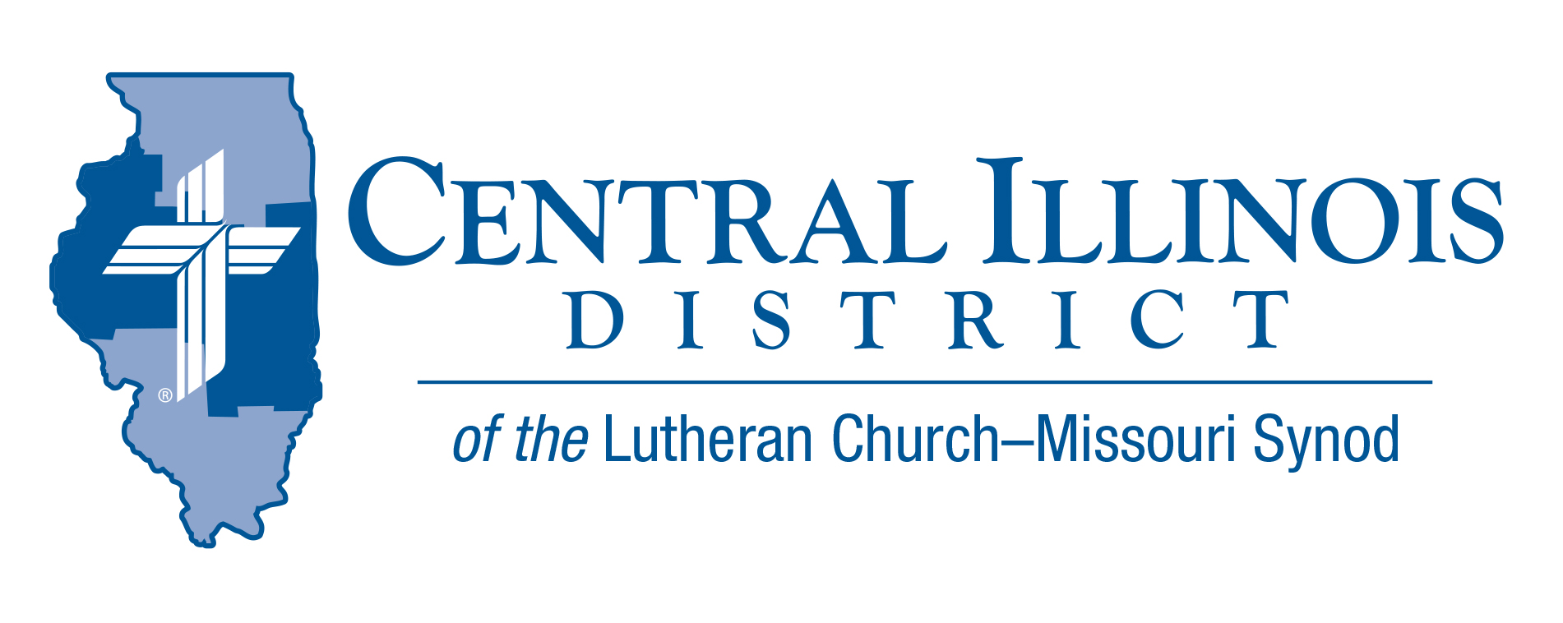
September 2026
News You Can Use
Devotional Message
The question has often been asked, “Is the Lutheran day school primarily a ministry to the children of our congregations or a mission to the unchurched children of our communities? The answer is, “Yes! Both!”
In the Small Catechism, Luther teaches us that the Holy Spirit calls us to faith in Jesus and then keeps us with Him in the true faith--both of which He does “by the Gospel.”
The Lutheran day school, where the Gospel enjoys pride of place throughout each school day, is the workshop of the Holy Spirit. In our schools, where the sword of the Spirit is unsheathed, the Spirit is at work calling unbelieving and unbaptized children to both faith and font. Through that same Word, he strengthens baptized and believing children to trust in Jesus more firmly and to love their neighbor more fervently.
Please support our schools with your prayers, offerings, and efforts. They provide the Holy Spirit with wonderful opportunities to do what only He can do—call students and their families to faith in Jesus and keep them with Him in the true faith.
Pastor Tibben – Trinity Lutheran Church -- Danville

Pray for Our Central Illinois District Missions, supported by your church’s regular contributions to the District.
Please remember our District’s mission work in central Illinois in your prayers.
Our Lord Jesus said, “Pray the Lord of the harvest to send laborers into the harvest.” This month, please remember in your prayers all the students, particularly those from CID, who are studying at our Synod’s colleges and seminaries to be pastors, teachers, and other kinds of church workers – many with the help of scholarship money from CID.

Our Redeemer Lutheran Church 50th anniversary
Sunday, November 1st, 2026

Come celebrate with us! Communion Service at 9:00 am at Our Redeemer - 405 Massey Lane, Jacksonville. Following the service, a feast at Hamilton’s Fireside Room (110 N. East St., Jacksonville)

RSVP by October 1 at sec1975orlc@yahoo.com (Cost $30 per adult and $15 per kid (age 6-12); under 5 are free.)

Payments by check to the church office by October 1st or pay online at https://www.paypal.com/ncp/payment/UMVURENVXJY94

“Rooted in Christ”:
CID Junior High Youth Event Set for November 7
Save the Date — Saturday, November 7 | Camp CILCA
Youth from across CID are invited to gather on Saturday, November 7, for a full day of worship, fellowship, and spiritual growth at Camp CILCA. This year's event carries the theme “Rooted in Christ,” drawn from Colossians 2:6–7, which calls believers to walk in Christ, “rooted and built up in Him and established in the faith.”
Registration will open at 8:30 a.m., with programming running until 4:00 p.m. Organizers are planning a day filled with worship, small-group discussion, and recreation, all centered on what it means for young people to grow deep in their faith and stand firm together as a community.
The cost to attend is $40 per youth, which covers the full day of activities. Adult volunteers attend free of charge, and organizers are encouraging churches to bring chaperones to support their youth groups throughout the day.
Camp CILCA, a longtime retreat and camp facility, offers a peaceful, natural setting well-suited for a day of reflection and connection. Registration is now open — churches and families can sign up using the link below.
Register Here https://pci.jotform.com/form/262385217608057

Lutheran Church Missouri Synod Convention Recap.
The 69th Regular Convention of The Lutheran Church— Missouri Synod, July 18–23, 2026, Phoenix Convention Center, Phoenix, Arizona.
The Convention Workbook, the Biographical Synopses & Statements of Nominees, and other materials — such as issues of Today’s Business and the convention Bible study — are available at https://www.lcms.org/convention/national
The opening Divine Service and all convention sessions are archived at https://www.lcms.org/convention/national/livestream

“Exploring God’s Mission Here” Workshop
God’s Mission Here workshop is for all our churches (and all the members who work together in the churches) to make sure that everyone “here,” around us, “hears” how Jesus saves us from sin, and why He is “the Way” to life with our heavenly Father. So this starting this year the CID is offering the workshop Exploring God’s Mission Here to all of our congregations. There you will get help focusing not only on God’s mission, but also on “here,” your congregation and its God-given assets, as well as your neighborhood (zip code) and what kinds of people are living here. It is best to get your whole circuit together to explore God’s mission here, because “here” can overlap, and the gifts we need to do God’s mission may be dispersed across congregations. So, if you haven’t yet been invited to one of these “Exploring God’s Mission Here” workshops, ask your pastor to ask your circuit when you can get the leaders of your congregations together (and invite President Eddy to lead you) in Exploring God’s Mission Here.

Our “Next God’s Mission Here” Workshop is scheduled for September 26th at Peace Lutheran Church– 200 W Arnold Ave, Thomasboro, IL.
While congregations in the Champaign, Iroquois, and Mattoon circuits are gathering at this workshop, other congregations/individuals are welcome. If you plan on attending this event and are not located in these circuits, please call the district office (217-793-1802) at least a week ahead. (We can make sure we have your demographic information.)

